**Business Problem**

In contemporary years, there has been observed high cancellation rates in both City hotels & Resort Hotels. Each hotel is currently catering to a plethora of issues as a result which includes low revenues & low foot-fall in the hotel rooms. Subsequently, the primary goal of both the hotel groups it to placate the increasing cancellation rates in order to augment their efficiency in revenue generation, and for us to provide them thorough suggestions to address this problem.

The cardinal topics of this report is the analysis of hotel booking cancellations as well as other factors that are not pertinent to the business and yearly revenue generation.



**Assumptions**

1. No unusual occurrences between 2015 and 2017 will have a substantial impact on the date used.
2. The information is still current & can be used to analyze a hotel’s possible plans in an efficient manner.
3. There are no unanticipated negatives to the hotel employing any advised technique.
4. The hotels are not currently using any of the suggested solutions.
5. The biggest factor affecting the effectiveness of earning income is booking cancellations.
6. Cancellations result in vacant rooms for the booked length of time.
7. Clients make hotel reservations the same year they make cancellations.

**Research Questions**

1. What are the variables that affect hotel reservation cancellations?
2. How can we make hotel reservations cancellations better?
3. How will hotels be assisted in making pricing & promotional decisions?

**Hypothesis**

1. More cancellations occur when prices are higher.
2. When there is a longer waiting list, customers tend to cancel more frequently.
3. The majority of clients are coming from offline travel agents to make their reservations.

**Analysis & findings**

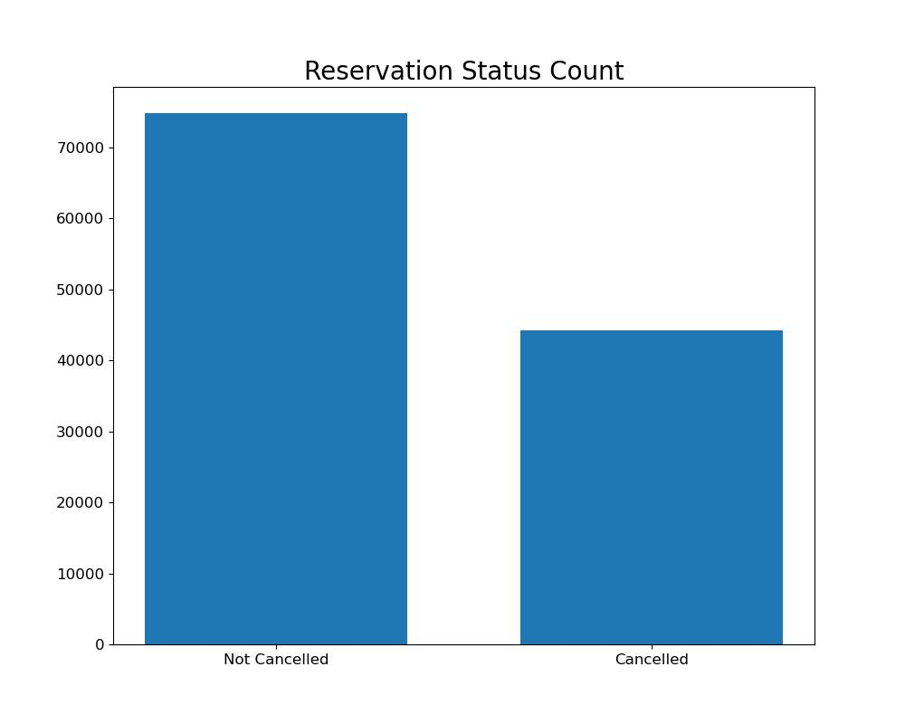

The above bar graph exhibits the percentage of reservations that are cancelled & those that are not. It is evident that there are still a significant number of reservations that have not been cancelled. There are 37% of clients who cancelled their reservations, yet it has a significant impact on the hotel earnings.

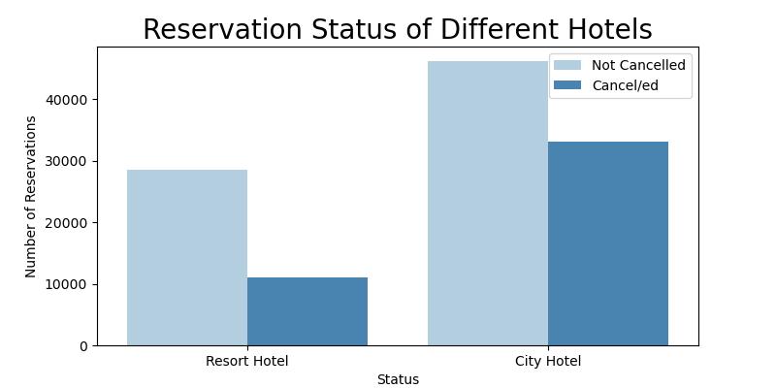

The above plot depicts the situation of both resort hotels & city hotels. The number of bookings in city hotels is comparatively higher than that of resort hotels. There lies a possibility that the resort hotels are more expensive than those in cities.

On the other hand, ther can be observed a much higher rate of cancellations in city hotels as compared to resort hotels.

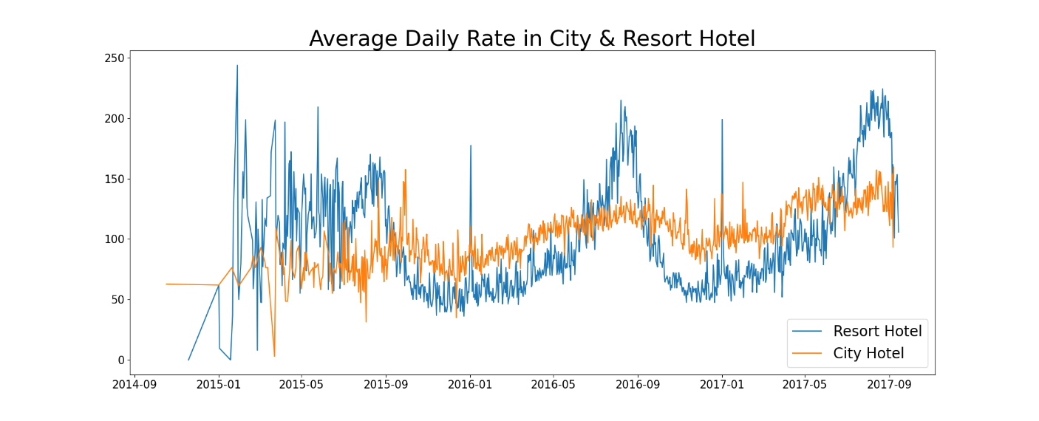

The line graph above portrays that, on certain days, the average daily rate of city hotels is more than that of resort hotels while on other days, the situation is opposite i.e. the average daily rate of city hotels is less than that of resort hotels. It goes without saying that weekends and holidays may observe a rise in resort hotel rates.

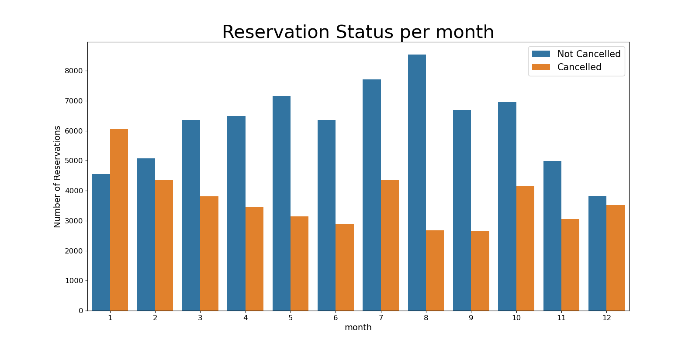

The above grouped bar graph was prepared to analyze the months with the highest and lowest reservation levels according to reservation status. As can be seen, the number of confirmed reservations was highest during the month of august and number of cancelled reservations is lowest during the month of august, which is equal to that of month of september. Where as January is the month with the most cancelled reservations.

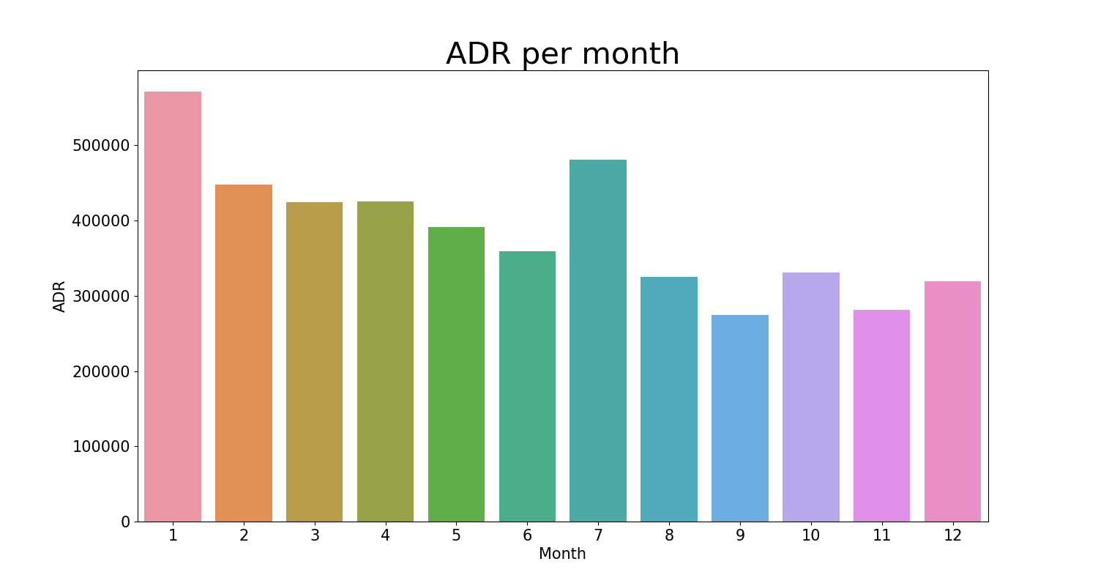

This bar graph represents that cancellations are most common when prices are high and are least common when the prices are lowest. Therefore, the cost of the accommodation is solely responsible for the cancellation.

Now, let us examine which country has the highest reservation cancelled. The top country is Portugal with the highest number of cancellations.

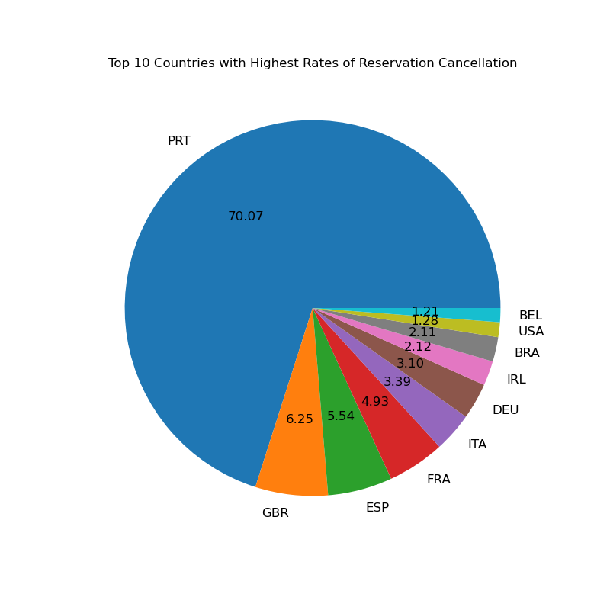

Let us inspect the area from where the guests are visiting the hotels and making reservations. It is coming from Direct or Groups, Online or Offline Travel Agents? Around 47.5% of the clients come from online travel agencies, where as 20.32 % comes from offline travel agents. Around 16.65% clients come from groups and about 12.45% clients book hotels directly by visiting them & making reservations.

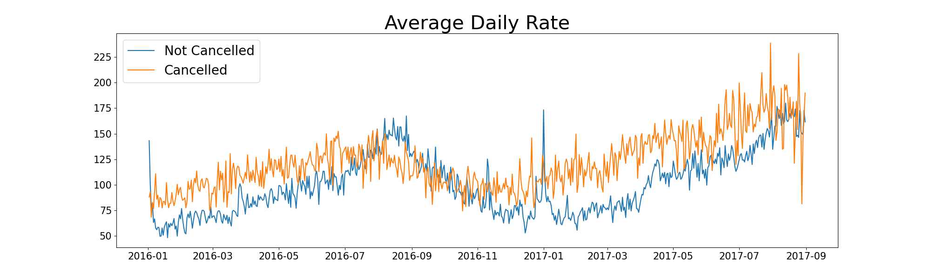

It is visible in the graph, reservations are cancelled when the average daily rate is higher than when it is not. It clearly proves all the above analysis, that higher prices leads to higher cancellations.

**Suggestions**

1. Cancellations rates rise as the prices incresaes. In order to prevent cancellations of reservations, hotels could work on their pricing strategies and try to lower the rates of specific hotesl based on locations. They can also provide some discounts to the consumers.
2. As the ratio of the cancelled and not cancelled of the city hotel is higher than that of resort hotesl, the city hotels should provide a reasonable discounts on the room prices along with some value-added services (if possible).
3. In the month of January, hotels can start campaigns or marketing with a reasonable amount to increase their revenue as the cancellation is the highest in this month
4. They can also increase the quality of their hotels & their services mainly in Portugal to reduce the cancellation rate.